CHAPTER 4: Using eLW in the First-Year Writing Program
What is eLW?
eLearning for Writers (eLW) is the First-Year Writing program’s digital writing tool that works with UGA’s online learning platform, eLearning Commons (eLC). eLW is designed for composing, collaborating on, and revising academic writing. Created from FYW’s previous platform, Emma, eLW offers a range of tools for writers and instructors. These include journal and brainstorming space, draft organization and comparison, and the ability to create comprehensive peer and instructor reviews at various stages of the writing process. Peer partners and instructors can provide holistic feedback, insert comments into a document, or use markup tags to identify common writing issues. eLW has been designed with years of instructor and student feedback to meet the needs of the First-Year Writing community.
Accessing eLW
eLW appears on the eLC menu of FYW courses, the same as other tools such as Discussions and Grades. Clicking the eLW menu icon will open eLW in a new tab.
Students do not need to register for eLW; they are enrolled from their FYW courses on eLC. eLW will only appear on courses that are approved and have installed eLW as a tool.
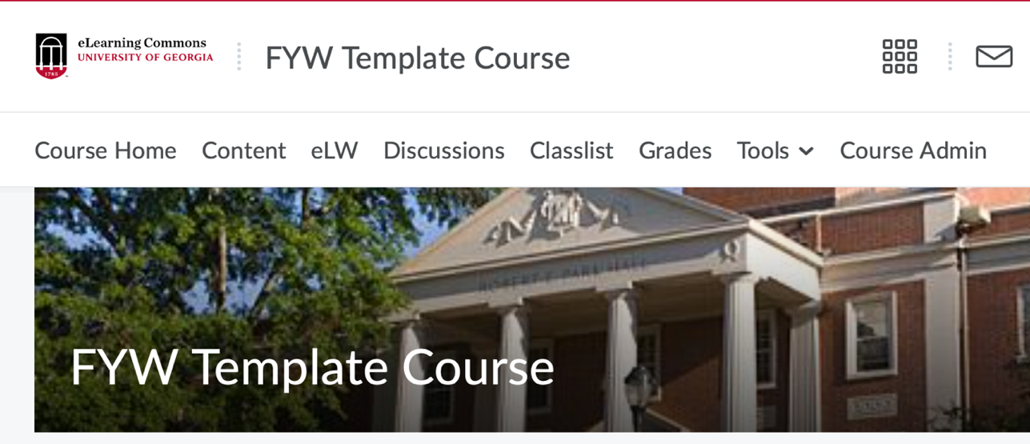
Projects
eLW is a project-based writing platform. All documents students create are organized by the projects and stages that instructors establish. The First-Year Writing Program encourages process writing, a practice that emphasizes each stage of composition.
Projects are the major assignments for FYW courses. The name of a project in the example below is “Drama and Film.” Each project will have its own stages, markup tags, and optional rubric sets as determined by your instructor.
Creating a Document
In the Documents tool, select New Doc to create a new document in eLW. Click the project for which you would like to create a document, and you will arrive at the document editor. A new tab with the open document editor will appear.
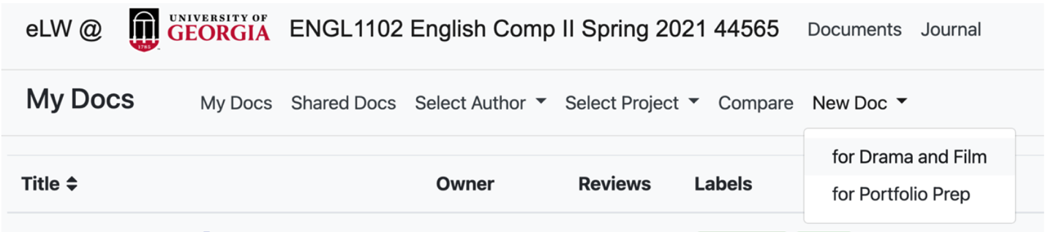
Once in the document editor, you may edit the title, choose the stage and access, and insert and edit text. The stage indicates where you are in the writing process for a project such as: brainstorming, first draft, final draft. Select which stage of your project you are working on, paying attention to any information your instructor provides about how to file your document in eLW.
Choose the access for the document. Private documents are only visible by the instructor and the student. Shared documents are available to the entire class. Typically final drafts are private and peer review documents are shared. Consult your writing prompt or your instructor if you aren’t sure if a document should be private or shared.
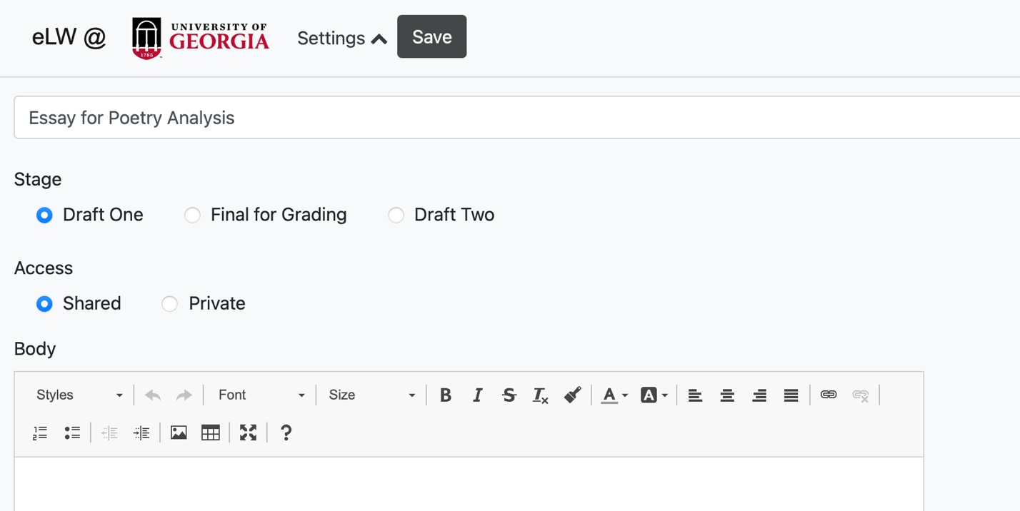
If you need to change the title, stage, or the access, click Edit after the document has been saved.
If you don’t see the stage or access selections, click Settings which may be collapsed to provide more screen space for the document editor.
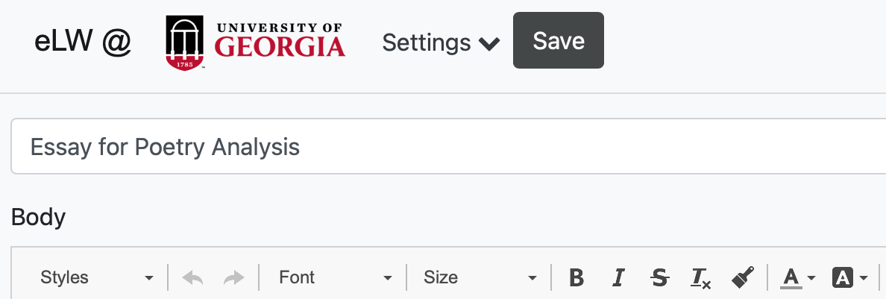
Once you have saved documents, you can organize and view them in the Documents tool. Each document is color coded for the project, access, and stage. To see only documents that you have created, select My Docs. To see documents your class has shared, select Shared Docs.
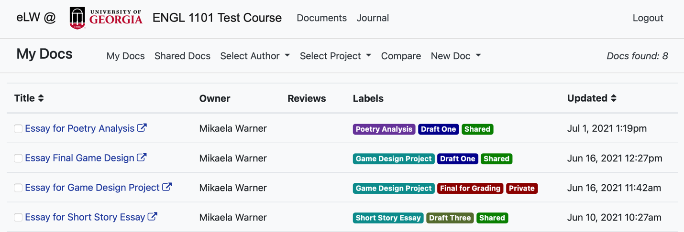
Reviews
Reviews are copies of a document that contain feedback or suggestions from an instructor or classmate. You create a review for a document that someone else owns and has shared. Select the document you want to review either by searching Shared Docs or choosing a specific author under Select Author.
When you select the specific title of the document you want, a new tab of that document in the will open. Select Create Review.
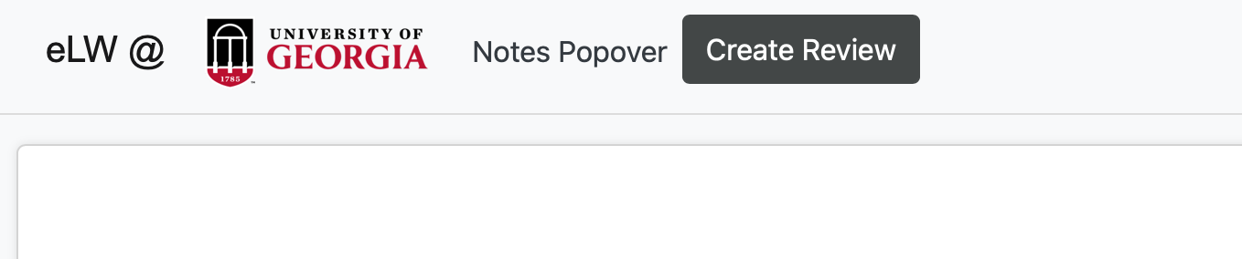
Once you create a review, you can edit the text, add markup, or insert a note. Any edits you make will be visible as a review but will not appear in the author’s original shared document.
All reviews will appear in the Document listings. A review you created for someone else will have a blue review icon and indicate the original author.
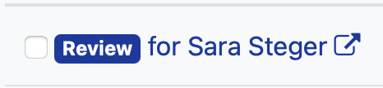
To view reviews that others have created for you, find your document under My Docs, and look in the Reviews column. A document with no reviews will have nothing in this column. If a document has reviews, click Reviews to select which review you want to view.
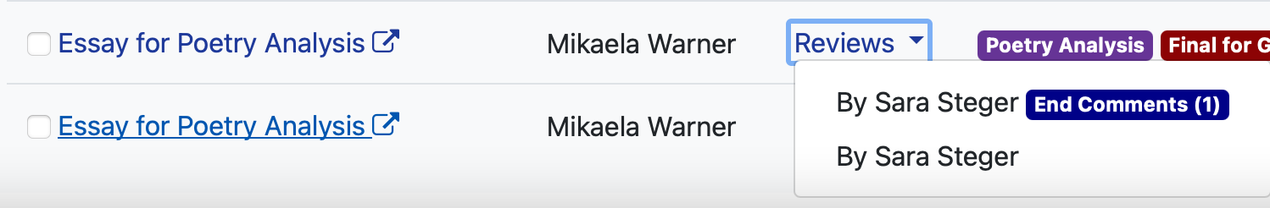
Markup
Markup are color-coded notes on the text that provide targeted feedback. Markup sets are customized by your instructor for each project. Markup appears on the right-hand side of the screen, or at the bottom in smaller browser windows. Some markup tags will link you to a resource to better understand the issue and offer strategies to revise.
To insert a markup tag, highlight the text you want to draw attention to, then select the markup tag under the markup sets available. Below we have selected Markup 4: Syntax and Style. The text you selected will now be highlighted in the tag color and have the specific feedback attached. You can add more than one tag to any part of the text.
To undo a tag you’ve inserted, press the backwards arrow in the text editor menu.
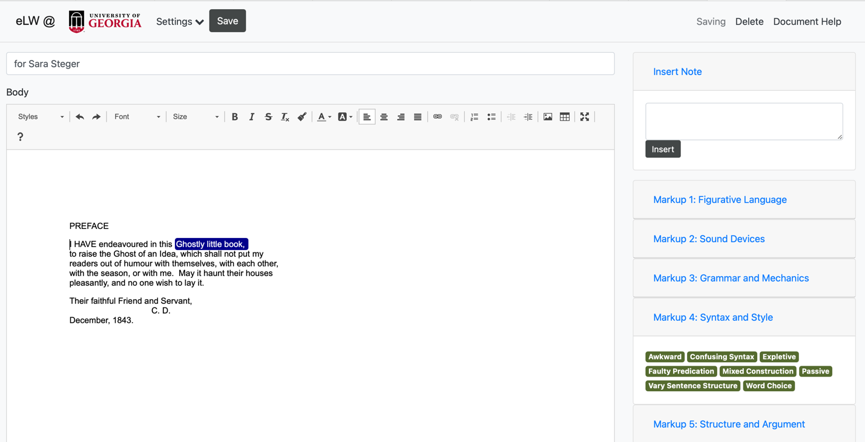

Notes are custom comments that you can insert directly into the text. To insert a note, highlight the text you want to comment on, write your note in the text box in the upper right-hand corner under Insert Note and select insert. A note will appear as blue text in a white bubble, while markup tags will appear as white text in dark colors.
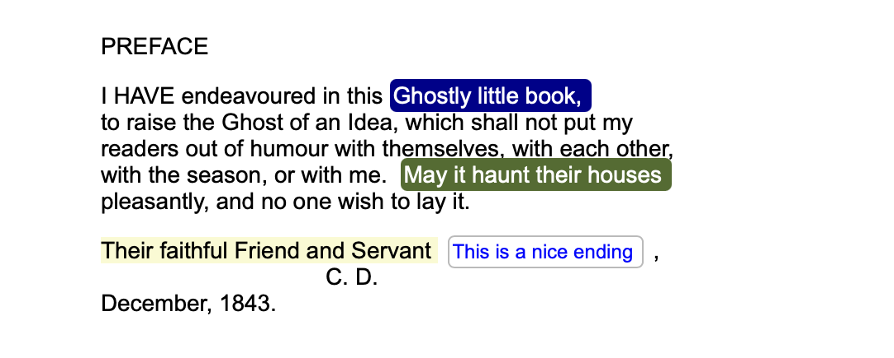
Selecting Save on a review will allow you to see all the markup and notes as the author will see them. You have two viewing options: Notes Inline and Notes Popover. Notes Inline inserts all feedback at the end of the document in footnotes. Notes Popover hides detailed feedback until you hover over the tag with your cursor.

You can change between Notes Inline and Notes Popover by selecting the option next to the Edit button.

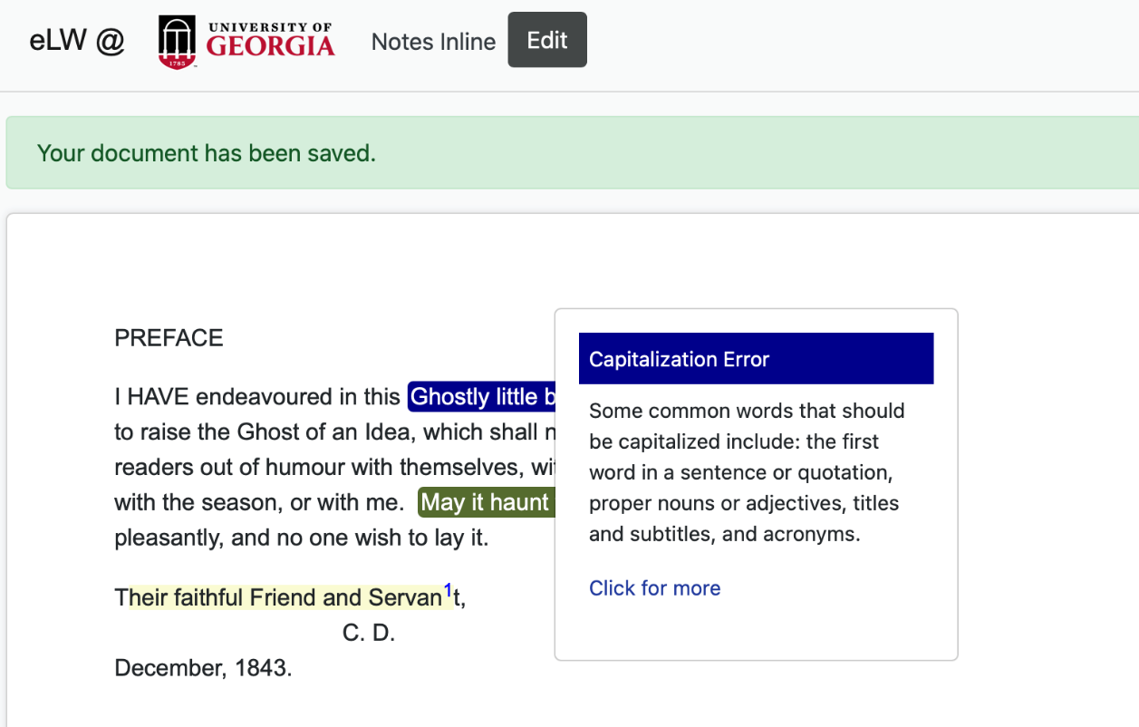

Compare Documents

eLW allows you to compare two different documents such as two drafts of an essay. In the documents listing, select the far left check box of the two documents you want to compare. Then select Compare from the documents menu. A new tab with the compared documents will open with changes color-coded.
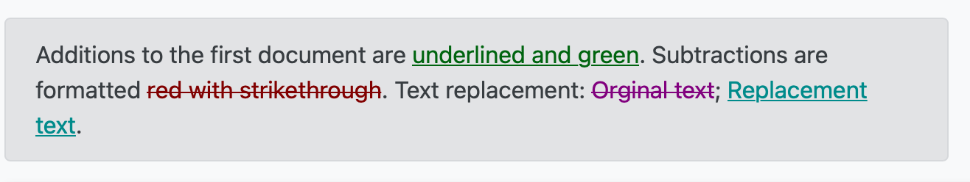
Journal
eLW includes a journal tool for writing that is seen only by you and your instructor. The journal tool is not intended for extensive editing or feedback, but for private low-stakes writing. Click the New Journal button to get started. Your instructor may offer feedback on your journals; these comments will display to the right of your posting.

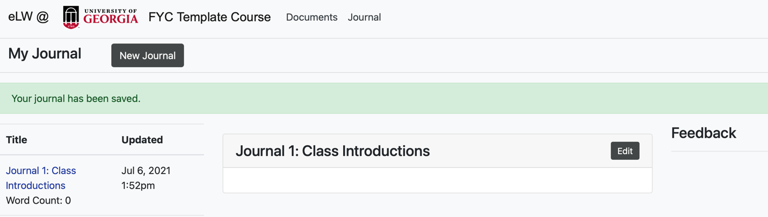
Technical Information
Students should always back up their eLW documents with files saved elsewhere in their preferred document format (OpenOffice, Word, etc.). We strongly recommend typing in a word processor (i.e. not online) and copy-pasting into eLW’s editor. As always when working online, students should save often and back up their work.
Formatting changes may happen when copying text from a different document into eLW, or when converting an eLW document into a PDF. Be sure to double check documents before submitting.
FYW Digital Learning Labs
The First-Year Writing Digital Learning Labs are located on the first floor of the new wing in Park Hall in Park Hall 117, 118, and 119. Digital Lab consultants work at the front desk of Park 118 and are available for walk-in help during work hours. You can check out a laptop for use in the instructional labs, check out a dongle to connect your laptop, and use the scanner in 118. If you intend to check out equipment, be sure to bring your UGA ID.
Contact consultants for eLW help via email at esupport@uga.edu.
Your instructor will let you know if you are scheduled to meet in the teaching labs. Park 117 has movable tables and six mediascape screens that are connected to desktop computers. Park 119 has projector screens and individual desks.

